Table of Contents

Business Model - Vertices 2

Services Under Each Vertex 4

IoT: 5

Robotics: 5

Embedded Systems: 5

Android: 5

AI: 6

IoT Services 6

Robotics Services 6

Embedded Systems Services 7

Android Services 8

AI Services 8

Resources Required for Each Vertex 9

# Business Model - Vertices

1. **IoT**: Create smart ecosystems to collect and analyse real-time data for optimized operations. Focus on connected devices, automation, and predictive insights.
2. **Robotics**: Innovate in robotics to enhance automation, safety, and efficiency in industries. Deliver intelligent solutions for manufacturing, healthcare, and services.
3. **Embedded Systems**: Design integrated hardware-software systems for efficient, high-performance applications. Target key sectors like automotive, electronics, and defence.
4. **Android**: Develop scalable Android apps with user-centric designs and seamless integrations. Focus on IoT, mobile innovation, and connected technologies.
5. **AI**: Deliver AI-powered solutions for automation, analytics, and decision-making. Enhance user experiences and optimize business processes across industries.

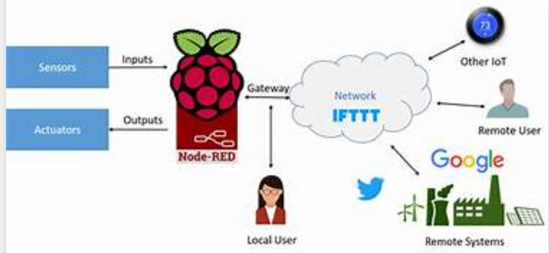

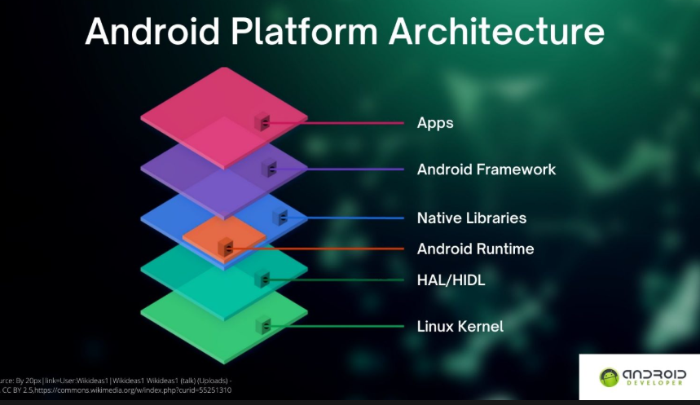

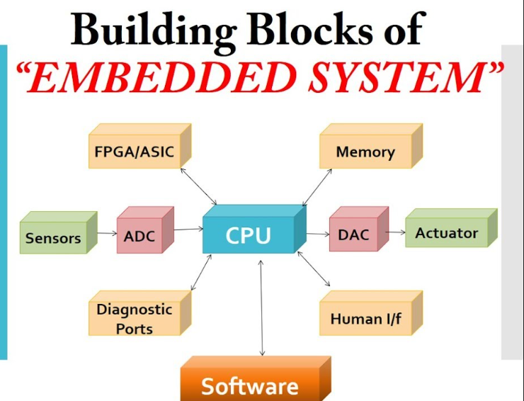

# 

# Services Under Each Vertex

## IoT:

* **Internal Training**: Equip teams with IoT expertise, focusing on device integration, data analytics, and network protocols.
* **Customized Workshop**: Offer tailored sessions on IoT technologies, smart devices, and real-world applications.
* **Engg Student Projects**: Guide students in designing IoT-based projects like smart homes, wearables, or industrial automation.
* **Customer-Driven Projects**: Develop bespoke IoT solutions for automation, monitoring, and predictive maintenance needs.

## Robotics:

* **Internal Training**: Provide hands-on training in robotics programming, design, and automation workflows.
* **Customized Workshop**: Conduct workshops on robotics, covering sensors, actuators, and AI integration.
* **Engg Student Projects**: Mentor students in building robotic systems for manufacturing, healthcare, or research.
* **Customer-Driven Projects**: Deliver tailored robotic solutions for industry-specific challenges and efficiency.

## Embedded Systems:

* **Internal Training**: Train teams in embedded systems design, including microcontroller programming and real-time OS.
* **Customized Workshop**: Facilitate workshops on embedded systems for targeted industry applications.
* **Engg Student Projects**: Support students in developing embedded projects like wearable tech or automotive solutions.
* **Customer-Driven Projects**: Create embedded solutions for industries like IoT, automotive, and consumer electronics.

## Android:

* **Internal Training**: Offer training on Android app development, UI/UX, and integration with other technologies.
* **Customized Workshop**: Design workshops on Android development for specific use cases, such as IoT or business apps.
* **Engg Student Projects**: Assist students in building innovative Android applications for real-world problems.
* **Customer-Driven Projects**: Develop custom Android apps tailored to customer requirements and business goals.

## AI:

* **Internal Training**: Provide training on AI concepts, tools, and frameworks for team upskilling.
* **Customized Workshop**: Deliver workshops on AI, covering machine learning, deep learning, and practical use cases.
* **Engg Student Projects**: Guide students in developing AI projects like chatbots, predictive models, or computer vision systems.
* **Customer-Driven Projects**: Design AI-driven solutions for automation, decision-making, and personalized user experiences.

# IoT Services

|  |  |  |  |
| --- | --- | --- | --- |
| **Service** | **Scope** | **Objective** | **Outcome/Expectations** |
| **Internal Training** | Train teams on IoT concepts, device integration, and data analytics. | Build in-house expertise to manage IoT systems. | Skilled workforce capable of deploying and maintaining IoT solutions. |
| **Customized Workshop** | Deliver tailored workshops on IoT use cases and technologies. | Equip participants with practical IoT implementation skills. | Enhanced knowledge of IoT applications specific to industries. |
| **Engg Student Projects** | Guide students in IoT-based project development. | Foster innovation and understanding of IoT systems. | Student projects demonstrating real-world IoT applications. |
| **Customer Projects** | Develop customized IoT systems for specific business needs. | Solve customer-specific challenges using IoT solutions. | Tailored IoT deployments enhancing productivity and monitoring. |

# Robotics Services

|  |  |  |  |
| --- | --- | --- | --- |
| **Service** | **Scope** | **Objective** | **Outcome/Expectations** |
| **Internal Training** | Train teams in robotic programming, design, and AI integration. | Build internal robotics expertise for automation tasks. | Skilled teams proficient in robotics technology. |
| **Customized Workshop** | Conduct workshops on robotics design and industry applications. | Enhance understanding of robotics for specific uses. | Participants adept at leveraging robotics in operations. |
| **Engg Student Projects** | Mentor students in creating functional robotics projects. | Encourage hands-on learning in robotics engineering. | Innovative student-led robotic solutions. |
| **Customer Projects** | Deliver robotics solutions for automation and precision tasks. | Meet industry-specific automation and safety needs. | Intelligent robotic systems solving real-world problems. |

# Embedded Systems Services

|  |  |  |  |
| --- | --- | --- | --- |
| **Service** | **Scope** | **Objective** | **Outcome/Expectations** |
| **Internal Training** | Train teams on embedded systems design and real-time OS usage. | Build internal expertise in embedded technologies. | Teams capable of creating efficient embedded systems. |
| **Customized Workshop** | Host workshops on embedded systems applications. | Equip participants with the knowledge to build embedded solutions. | Enhanced industry-specific embedded systems knowledge. |
| **Engg Student Projects** | Support students in developing projects like smart wearables. | Foster innovation in embedded system designs. | Functional student projects showcasing embedded technology. |
| **Customer Projects** | Develop custom embedded solutions for industrial applications. | Solve unique customer challenges with tailored systems. | Reliable embedded systems meeting business demands. |

# Android Services

|  |  |  |  |
| --- | --- | --- | --- |
| **Service** | **Scope** | **Objective** | **Outcome/Expectations** |
| **Internal Training** | Train teams on Android development and IoT integration. | Build skills in Android app development. | Teams capable of creating robust Android applications. |
| **Customized Workshop** | Conduct workshops on Android use cases and development. | Enhance knowledge of Android tools and techniques. | Participants skilled in creating effective mobile apps. |
| **Engg Student Projects** | Mentor students in developing Android-based innovative apps. | Encourage practical learning in mobile development. | Innovative student projects solving real-world problems. |
| **Customer Projects** | Develop tailored Android apps for specific customer needs. | Address unique business challenges through mobility. | User-friendly apps improving business operations. |

# AI Services

|  |  |  |  |
| --- | --- | --- | --- |
| **Service** | **Scope** | **Objective** | **Outcome/Expectations** |
| **Internal Training** | Train teams on AI tools, frameworks, and applications. | Build in-house AI expertise for business innovation. | Skilled teams capable of leveraging AI for problem-solving. |
| **Customized Workshop** | Deliver workshops on machine learning, deep learning, and AI. | Provide hands-on training in AI techniques. | Participants skilled in applying AI to diverse challenges. |
| **Engg Student Projects** | Guide students in AI-based projects like chatbots and models. | Promote innovation and learning in artificial intelligence. | Functional projects demonstrating AI potential. |
| **Customer Projects** | Develop AI-driven solutions tailored to customer requirements. | Enable automation, analytics, and smart decision-making. | AI systems providing competitive business advantages. |

# Resources Required for Each Vertex

|  |  |  |  |  |
| --- | --- | --- | --- | --- |
| **Vertex** | **Hardware (HW)** | **Software (SW)** | **Skill Set** | **Number of People** |
| **IoT** | IoT devices, sensors, microcontrollers, gateways, network hardware. | IoT platforms, data analytics tools, cloud services. | IoT developers, network engineers, data analysts. | 2-4 |
| **Robotics** | Robotic kits, actuators, sensors, control systems. | Robotics programming tools, AI integration platforms. | Robotics engineers, AI specialists, mechanical designers. | 2-4 |
| **Embedded** | Microcontrollers, development boards, oscilloscopes, testers. | Embedded IDEs (e.g., Keil, MPLAB), real-time OS. | Embedded system developers, firmware engineers, hardware testers. | 2-4 |
| **Android** | Mobile devices, testing hardware, deployment infrastructure. | Android Studio, version control systems, APIs. | Android developers, UI/UX designers, testers. | 2-4 |
| **AI** | High-performance GPUs, servers, cloud computing infrastructure. | AI frameworks (TensorFlow, PyTorch), data pipelines, analytics tools. | Data scientists, AI engineers, ML model trainers, software engineers. | 2-4 |